Professor Hugh Possingham FAA BSc (Adelaide) DPhil (Oxford)

Australian Research Council Federation Fellow 2006-2011

Professor of Mathematics and Professor of Ecology, The University of Queensland

Director of The Australian Research Council

Centre of Excellence for Environmental Decisions http://ceed.edu.au/ 2011-2018

Born in 1962, Hugh accidentally completed honours Mathematics at The University of Adelaide in 1984 (top of class). After attaining a Rhodes Scholarship he completed his DPhil at Oxford University in 1987 in biomathematics. An ARC QEII Fellowship ANU in 1989 followed, then a postdoc with Joan Roughgarden at Stanford modeling marine populations. In 1990 he took a tenure-track position in Applied Mathematics. He became a Professor and Foundation Chair of Environmental Science in 1995, aged 32, and then moved to become Head of the Ecology Centre at The University of Queensland in 2000.
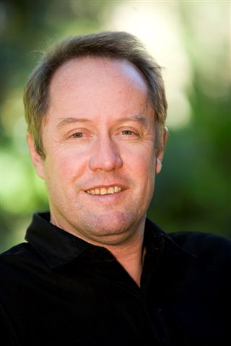
Hugh has a variety of broader public roles advising policy makers and managers sitting on 16 committees and boards outside the University including: The Wentworth Group of Concerned Scientists (founding member), Queensland Smart State Council, Chief Editor of Conservation Letters (an international scientific journal, IF 4.7), Council of the Australian Academy of Science, and ENGO scientific advisory committee. He and Dr Barry Traill wrote “The Brigalow Declaration”, used by Premier Beattie to stop land clearing in Queensland thereby securing at least 1 billion tonnes of CO₂.

The Possingham lab developed the most widely used conservation planning software in the world. Marxan www.ecology.uq.edu.au/marxan.htm was used to underpin the rezoning of the Great Barrier Reef and is currently used in over 100 countries by over 2500 users – from the UK to Brazil. Australia is using Marxan to help it rezone its entire EEZ (2% of the planet). Hugh gave the plenary address at the first Marxan conference in Vancouver in April 2007. Other work has revolutionised the way organizations prioritise decisions.

Hugh has coauthored over 300 refereed publications covered by the Web of Science (21 in Science, Nature or PNAS) and has 7500 Web of Science citations resulting in an h-index of 47. He currently directs two research centres, each of c$15 million, and he has supervised 51 PhD students and 32 postdoctoral fellows..

Hugh has been awarded: the POL Eureka Prize for Environmental Research, 1999, the inaugural Fenner medal for plant and animal biology from the Australian Academy of Science, 2000, the Australian Mathematical Society Medal, 2001, ARC Professorial Fellow, 2003, Fellow of the Australian Academy of Science, 2005, ARC Federation Fellow, 2006, Sherman Eureka Prize for Environmental Research, 2009.

Some recent plenary addresses include: The Society for Conservation Biology meeting, Sth Africa 2007; the Australian Society for Operations Research, 2009; and the 8th International Conference on Behaviour, Physiology and Genetics of Wildlife, Berlin 2011. Recent media includes discussions of: triage, assisted colonization (a Science policy forum paper), national biodiversity policy, marine reserves, the Kimberley biodiversity plan, declining woodland birds, carbon and biodiversity and the conservation of travelling stock routes in Australia. He suffers from obsessive bird watching and delivers about 30 public addresses per year.

